**DAILY ONLINE ACTIVITIES SUMMARY**

|  |  |  |  |  |  |  |  |  |
| --- | --- | --- | --- | --- | --- | --- | --- | --- |
| **Date:** | **25/07/2020** | | | | | **Name:** | **NAIPUNYA VINOD NAIK** | |
| **Sem & Sec** | **IV SEM & A SECTION** | | | | | **USN:** | **4AL18CS050** | |
| **Online Test Summary** | | | | | | | | |
| **Subject** | | **NO INTERNALS CONDUCTED** | | | | | | |
| **Max. Marks** | | **30** | | **Score** | | | **-------------------** | |
| **Certification Course Summary** | | | | | | | | |
| **Course** | **1) GOOGLE CLOUD PLATFORM BIG DATA AND MACHINE LEARNING FUNDAMENTALS** | | | | | | | |
| **Certificate Provider** | | | **COURSERA** | | **Duration** | | | **2 WEEKS** |
| **Coding Challenges** | | | | | | | | |
| **Problem Statement: CONQUER CONDITIONALS HACKERRANK PROBLEM** | | | | | | | | |
| **Status: EXECUTED** | | | | | | | | |
| **Uploaded the report in Github** | | | | | **YES** | | | |
| **If yes Repository name** | | | | | <https://github.com/naipunya-naik/Online-Coding-platform-coding/blob/master/Conditionals_25-07-2020.java> | | | |
| **Uploaded the report in slack** | | | | | **YES** | | | |

Online Test Details: (Attach the snapshot and briefly write the report for the same).

NO INTERNALS CONDUCTED

Certification Course Details: (Attach the snapshot and briefly write the report for the same).

CERTIFICATION COURSE NAME:- **GOOGLE CLOUD PLATFORM BIG DATA AND MACHINE LEARNING FUNDAMENTALS.**

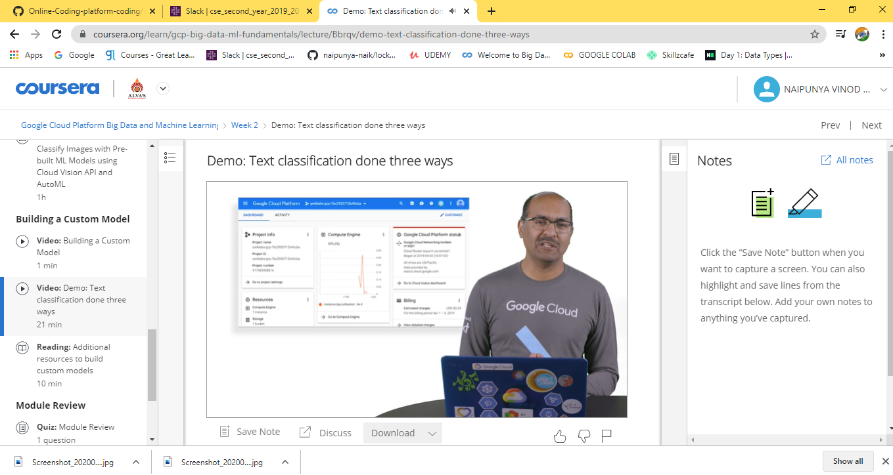

Coding Challenges Details: (Attach the snapshot and briefly write the report for the same).

PROBLEM STATEMENT:- **Task**  
Given an integer, , perform the following conditional actions:

* If  is odd, print Weird
* If  is even and in the inclusive range of  to , print Not Weird
* If  is even and in the inclusive range of  to , print Weird
* If  is even and greater than , print Not Weird

Complete the stub code provided in your editor to print whether or not  is weird.

**Input Format**

A single line containing a positive integer, .

**Constraints**

**Output Format**

Print Weird if the number is weird; otherwise, print Not Weird.

**Sample Input 0**

3

**Sample Output 0**

Weird

**Sample Input 1**

24

**Sample Output 1**

Not Weird

I ATTEMPTED THE QUESTION AND PASSED TWO TESTS OF THE

PROBLEM.

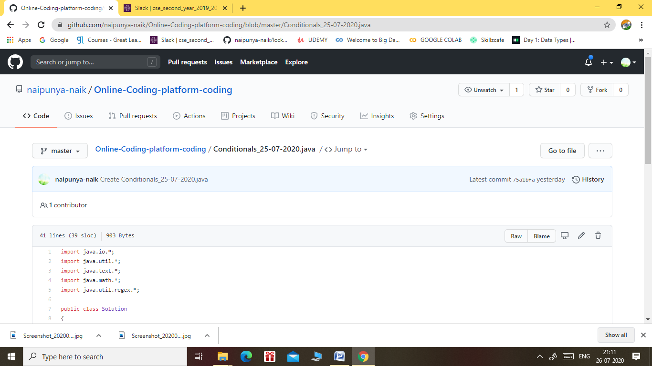

GITHUB REPOSITORY LINK:-

<https://github.com/naipunya-naik/Online-Coding-platform-coding/blob/master/Conditionals_25-07-2020.java>